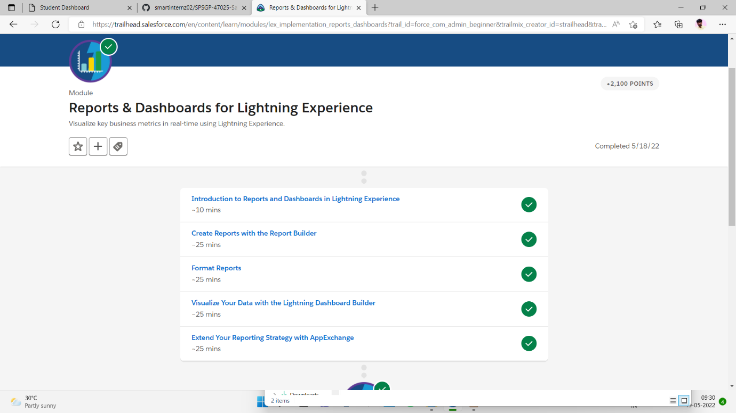

Sub topic:- Create Reports with the Report Builder

In this I learn lot of thing I struggled and finally completed in this only I am unable to click apply button and I clicked something I tried lot of finally go result

